



MIRAI PROJECT REPORT

Natural Language Processing

in Demand Forecasting



December 20, 2022

GROUP 9C

Jeremy Tan – Product Owner

Nicole Teoh – Scrum Master

Beatrice Yap

Adam Chen

Maggie Mak

Table of Contents

Executive Summary 4

Introduction 6

Analysis of the Problem 8

Most Forecasts Model Are Quantitative 8

Qualitative Forecast is a Manual Process 8

Short Lifespan of Forecasts: Automated is Better 9

As-Is Customer Journey 9

To-Be Customer Journey 10

Industry Analysis 11

Competitive Analysis 13

Target Audience 15

Proposed Solution 16

NLP-Based Demand Forecast 16

Cause-Effect Modelling 17

Data Preparation 17

Build, Train and Evaluate Model 20

Temporal Extraction 20

Design and Prototype 22

Product Inspiration 22

Wireframing Using PowerPoint 23

Prototype Design 24

IT Landscape 25

Feasibility Analysis 26

Economic Feasibility 26

Improved Accuracy 26

Enhanced Speed 26

Enhanced Efficiency 26

Reduce Costs 26

Value Chain Analysis 27

Technology Feasibility 28

Schedule Feasibility 28

Financial Aspects 30

Revenue streams 30

Time and Material 30

Fixed Price 30

Sprint Pricing 31

Project Venture Business Outlook 32

Kaizen/ Agile Methodology 33

Change Management 34

Communication Plan 34

Implementation through Collaboration 34

Risk Management 35

Timeline and Skillset 35

Technology 35

Conclusion 36

Demonstration and Documentation of Solution 38

Overall Process 38

Step 0: Visit MIRAI Website 38

Step 1: Visit the Dashboard 38

Step 2: Upload the data 38

Step 3: Demand Forecast Chart 39

Step 4: Event Detail 39

Step 5: Impact Table 40

Step 6: Upload the data 40

Python Codes 40

References 41

Appendix 44

PowerBI Prototype 44

Agile Methodology 44

Daily Standup 44

Kanban 45

TEAMS Collaboration – Internal & Stakeholders 45

Information Repository – One Note 45

Retrospectives 46

Lean Canvas 47

Time Log 48

# Executive Summary

As our final capstone project, we look to help Panasonic improve their demand forecasting using Natural Language Processing (NLP). Currently, demand forecasting is done based on quantitative data, i.e., past trends, economic indexes, industry indicators. With this project, we aim to outline a roadmap to incorporate qualitative data through news as an initial media to improve the demand forecast.

In the current scope of the project, we would be focusing on the demand forecast for EV (Electric Vehicle) Relays for Panasonic. The automotive relay market is projected to expand to USD 41.8 Billion by 2030 (Precedence Research, n.d.) (Singh, 2022). In 1980, electronic parts were only 10 percent of a total car cost. As cars become more autonomous, it is projected in 2030 that electronic parts will make up to 50 percent of a cost of a new car, similar components would be used in other kinds of transportation vehicle, i.e., buses and trucks. (Placek, 2022)

Figure 1: Electric Vehicle (EV) Relay Market Size, 2021 to 2030 (USD Billion) (Precedence Research, n.d.)

The common demand forecasting methods include (Rheude, 2022):

1. Trend Projection
2. Econometric
3. Sales Force Composite
4. Delphi Method
5. Market Research

However, these methods are done in silo. Many of the information from each method interact closely with each other. Therefore, blending and combining all available data as inputs of a single forecasting model is the best way forward. (Pentecoste, 2022)

While there are many demand forecasting and business intelligence solutions out there, most of them are tailored to the retail market. In the case of Panasonic, they would benefit from a customised model tailored to forecasting EV relays demand. Currently, Panasonic’s data science team has successfully integrated the quantitative forecasting methods using Artificial Intelligence within their dashboard. In our project, we explore the use of Natural Language Processing and Machine Learning to including news scrapings from the web to augment their demand forecasting data, for the Sales and Marketing teams to make more informed decisions.

# Introduction

According to Panasonic’s 2022 Financial Report, 50% of Panasonic’s automotive component profit margins come from the sales of EV Relays. Global EV Relay main manufacturers are Panasonic, Xiamen Hongfa Electroacoustic and Denso, totally accounting for about 60% of the market. (Research Reports World, 2022) If Panasonic is to remain as one of the major producers, it would be crucial to have a demand forecasting platform to aid them in strategizing their sales, marketing, and production while proactively manage the continuous changing market conditions. This would in turn, reduce costs and maximise profits:

1. Improve production lead times
2. Increase operational efficiencies
3. Optimise inventory levels
4. Identify and rectify any issues with the sales pipeline
5. Ensure supply matches customer demand

Figure 2: Sales of Panasonic Corporation in fiscal year 2022, by segment (Panasonic Group, 2022)

An example of a recent market shift would be the current global semiconducting processing chips shortage which have affected many industries and products segments, including automotive. This shortage started in early 2020 and continues to this day. In the current VUCA (volatile, uncertain, complex, and ambiguous) (Placek, 2022) environment, companies that can predict this event, spot the supply/demand shift, or react to the changing market quickest would benefit the most.

Figure 3: Projected revenue and production loss of the global automotive industry as a result of the semiconductor chip shortage in 2021

We have partnered with the Panasonic’s Data Science Team to explore the use of Natural Language Processing to improve their demand forecasts. While a 100% forecast accuracy is impossible, it is possible to add different methods to improve forecasts accuracy and enable users to act on it faster.

The objective of this project is to:

* Outline a roadmap to improve EV Relay demand forecasting using qualitative data for Panasonic’s sales and marketing team
* Bring about higher efficiency in project delivery through the Agile Working Model

The deliverables of this project include:

* A prototype of an app for sales and marketing to understand the relationship of news in relation to the product demand
* A natural language processing model that identifies lexicon-based relation
* A natural language processing model that extracts text with temporal information
* A report listing all the details of the project, the economic value added and implementation steps and recommendations

# Analysis of the Problem

## Most Forecasts Model Are Quantitative

Quantitative forecasting models rely on demand trends and seasonality to help make the predictions more accurate. In these models, it is imperative to have sufficient, decent quality data about the past to make a reasonable assessment about the future. In addition, we must assume that history is a good indicator of the future for these models, which is not always true.

Qualitative forecasting models are based on expert opinions and insights based on experience. These insights could come from one person or multiple people both internally and externally to the business.

The issue at hand is that most demand forecasting systems have been built to take in quantitative inputs, and qualitative inputs are not accounted for in an integrated and holistic manner in these systems. Users of these systems are only able to generate a system-calculated forecast for numerical data types like historical sales and economic data, but industry intel in the form of news articles and customer feedback have no bearings on the generated forecast.

A study carried out in 2020 showed that rather than relying solely on quantitative or qualitative data, a forecast based on both types of data showed superior performance (Leenatham & Khemavuk, 2020). In conclusion of that study, it is important to incorporate qualitative data to increase the accuracy of demand forecasts.

## Qualitative Forecast is a Manual Process

Qualitative methods of forecasting are done manually and are time intensive. These methods include the Delphi Model, Sales Force Opinion and Market Research (Plex DemandCaster, n.d.).

1. The Delphi Model is an iterative process where a panel of industry experts are asked to generate the forecasts. It is an iterative process which involves back-and-forth discussions to achieve a consensus forecast.
2. Sales Force Opinion is based on the sales team submitting a forecast for their respective area. The forecasts are reviewed by senior managers and then become aggregated into a demand forecast.
3. Market Research uses customer surveys to find potential demand. The survey may include personal, demographic, and economic information. The results of these surveys are aggregated before putting into a demand forecast.

Demand Forecasting analysis in Panasonic is currently done manually through extraction of data from the Database into MS Excel. This process usually takes up 60% of the Sales Analyst’s time. Since it is a manual process, it is also open to human biases, and based on the person preparing the report. In addition, the analysis or interpretation is based on the knowledge of the Analyst, who may not have full exposure and understanding.

For organizations without a Sales Analyst, this responsibility often falls upon the Sales Managers and Head of Departments. These sales users (rather than just the Analyst) are often industry domain knowledge experts who will be useful in developing and managing forecasts. However, forecasting becomes a competing area of focus which may not be part of their KPI (Key Performance Indexes) as most sales-related roles are measured on achieved sales and not forecasting. Forecasting could also be down the priority list as the task is time-intensive and laborious.

## Short Lifespan of Forecasts: Automated is Better

Forecast is difficult and never 100% accurate. The goal has always been to increase the accuracy of any forecast to reap its promised benefits. All forecasts are based on selected parameters, variables, timescale, and data points, both quantitative and qualitative. The more data points, the more accurate the calculation is.

However, the higher the accuracy rate, the more sensitive it is to change as each of these data points, each variable, each parameter may change at any time due to many factors. These changes may be direct or indirect, internally, or externally initiated. Many of the external factors are outside the control/influence of the company. Furthermore, the further into the future the forecast is projected, the less reliable/accurate the forecast is typically.

The true value generated from any forecast is derived from the degree of accuracy over a specific period on which the product/service/operations forecast is for. Forecasts immediately becomes obsolete once variables that drive the forecast changes, or some adverse change has occurred. Thus, it makes a case for developing an automated forecast for qualitative methods.

## As-Is Customer Journey

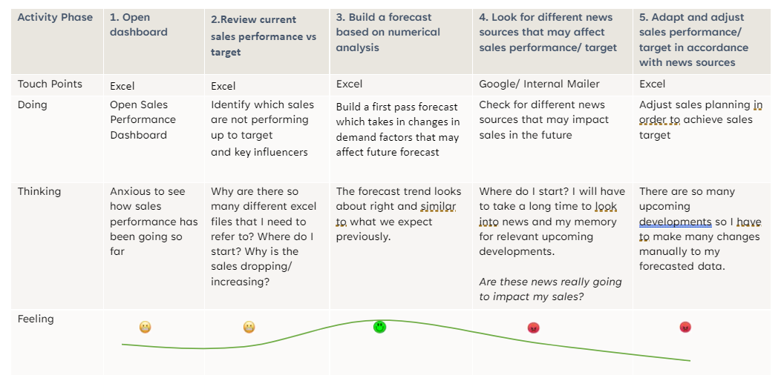

Figure : As-is Customer Journey

## To-Be Customer Journey

Figure : To-be customer Journey

# Industry Analysis

There are many companies addressing the demand forecast challenge, each targeting different industries, segments, and subset of the challenges. They each approach the challenge differently.

Most use historical quantitative data coupled with limited/selective discrete external “live” data set such as weather, traffic patterns, general market (retail) pricing, and commoditized pricing (material, energy, and transport) to find a relationship to develop a demand forecast. Promotions, campaigns, and seasonal trends are used as well. The correct selection of model(s) and continuous improvements of model designs is essential.

AI might seem to be a cure-all for all issues; however, these are the 3 AI’s which are believed to be critical (Cannone, 2021):

1. Automated integrations of data to enable faster and real-time decision-making
2. Actionable intelligence for developing insight
3. Augmented intent data that aggregates multiple data types

Figure The Evolution of Forecasting (Kabongo, 2021)

Businesses recognise the need to adopt better tools to address different business/operational requirements. McKinsey & Company’s survey presents a sample snapshot of leading supply-chain companies, all in various stages of implementation and investment. There is a recognized need for improved forecasting tools using machine learning.

Figure 7 Implementation Status of Supply-Chain Leaders expected or already using AI and Machine Learning (Marilú Destino, 2022)

## Competitive Analysis

While there are many distinct types of forecasting tools available, each with varying degree of complexity, industry specialty, and dependence on traditional MIS systems such as ERPs (Enterprise Resource Planning) and CRMs (Customer Relationship Management), a McKinsey & Company survey in 2021 has found that most of its respondents rely primarily on using a spreadsheet for its planning. These manual methods of Forecasting and Demand Planning are highly user-dependent, time-consuming, limited, and error-prone.

Figure Spreadsheets remain top method for supply-chain planning (Marilú Destino, 2022)

Most available AI-driven demand forecasting tools are geared towards B2C segment, not B2B. Current available solutions do not use NLP to translate news into impact points with value for demand forecast. Our solution is designed and geared towards being an augmented analytical tool. It adds to existing quantitative forecasting models. It can be used primarily for the purpose of identifying adverse or opportunistic events that will trigger the need to adjust demand forecast while maintaining the overall goal of reduce stock out, loss sales opportunity, replenish optimization, logistics planning, increase/capitalize sales, etc; to increase the possibility of achieving the benefits expected from improved demand forecasting. As an automated tool, it can constantly analyse events and provide quicker, relevant, and accurate insights.

Here is a snapshot of some competitors:

|  |  |  |
| --- | --- | --- |
| REMI AI | Zebra/Antuit AI | C3 AI |
| [https://www.remi.ai](https://www.remi.ai/) | <https://www.zebra.com/> | [https://c3.ai](https://c3.ai/) |
| Target Market | | |
| Retail, Retail Consumer Manufacturing, and ECommerce | Consumer Products, Retail | Discrete Manufacturing, Oil & Gas, Utilities, Financial Services, Government, Healthcare, Retail, Telecommunication, Transportation, Defence & Intelligence |
| Key Capabilities | | |
| * Demand sensing AI * Demand forecasting AI * Inventory planning * Inventory Optimization AI * Price Optimization AI | * Demand Forecasting – Consumer Demand * Demand Planning – Enterprise * Demand Forecast & Planning – Omnichannel Demand * DSD (Direct Store Delivery) Predictive Ordering * Intelligent Order Promising * Allocation Optimization * Replenishment Optimization | * Time-based graph network * AI-powered link analysis * Event-based exploration * Single unified data model * AI-powered pattern identification * Deep investigative analysis * AI CRM * No-code AI |
| Technology | | |
| * Machine learning, demand sensing, datasets (weather, events, promotions), demand triggers, * 14 different time series methods, including recurrent neural networks, deep learning, probabilistic, ARIMA | * AI/ML demand model development, ML Ops and pipelines, Application development | * Visual Studio, JupyterLab, Time series data management, Enterprise Catalogue, * AI/ML model development, ML Ops and pipelines, Application development, Lime, SHAP, ELI5 |

## Target Audience

This solution is designed initially for sales & marketing professionals. However, the same technology can be used for any decision maker in the organization who is involved in or requires:

* improved forecasting capability
* live monitoring of external events with notification alerts
* analysis of events
* operational planning and management
* sales planning and operations
* business development
* strategic planning and investment

Ideally, this solution would be well suited for B2B organizations with:

* high value inventory
* critical components / parts / spare parts
* high holding cost
* multiple SKUs
* complex supply chains
* sales demand is dependent on the demand of customers’ products / services

# Proposed Solution

Prior to the onset of NLP, there was no way to convert qualitative inputs to a quantitative input which can be aggregated into a demand forecast. Developments in NLP, which involves building machines that understand and respond to text or voice data, has opened this area of opportunity for further development.

The adoption of NLP for sentiment is slower and more challenging due to:

1. Limited available solution
2. Data not readily available for B2B ie, reviews, tweets, survey feedback, etc
3. Small and inconsistent data set

To solve this problem, our solution focuses on news events. News events can be considered as a form of sentiment. These are more readily available when the definition of news is kept broad to include news, industry/trade articles, market opinions, product releases, etc. Any form of textual information that has a direct or indirect implication to the company’s business and can be taken into consideration for some action to be taken.

## NLP-Based Demand Forecast

Together with the data science team at Panasonic, we are proposing a pipeline of 4 modules to build a demand forecast model based on news articles.

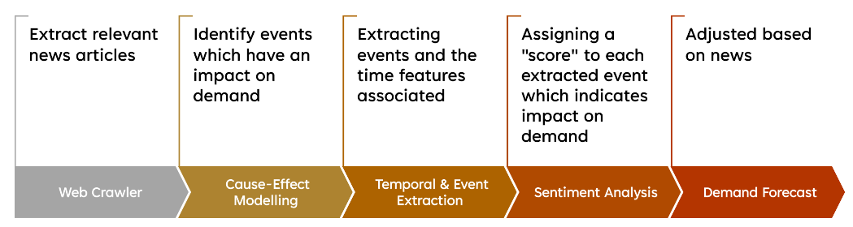

Figure Pipeline for NLP-Based Demand Forecast

In this pipeline, we start off with a web crawler which extracts news articles from news sources like Reuters, BBC, CNN. In addition to recognizing and extracting the news content in these websites, the web crawler will also model topic identification. This enables it to return industry-relevant news articles. In our project with Panasonic, they had already built such a web crawler prior, and thus, we did not replicate the work they had already done. We note that there are existing solutions in the market for this, for example: NewsAPI, which returns JSON search results for current and historic news articles published by over 80,000 worldwide sources (NewsAPI, n.d.). Should we need to replicate the solution for an alternative client, we will work on integrating such alternatives into our solution.

The second module in this pipeline is a cause-effect model. This module helps to establish relationships between events. Passing relevant data through the model can help to identify events that have a causal relationship with the demand. This will help focus the subsequent modules in our pipeline on relevant events, instead of all events.

The third module is a temporal and event extractor, which extracts events and time features associated with these events from the news article. This is important in identifying when specific events will happen. Take for example, a news article written in Nov 2022 which might state “Germany will electric car subsidies in Aug 2023”. Typically, web crawlers return the date of the news article in a separate field, but dates and time information in the text cannot be extracted. Only with a temporal extractor will we be able to pick out the date of Aug 2023, which is more relevant to the demand impact than Nov 2022.

The fourth and last module works towards establishing a quantitative relation between events and the demand so that these events could be used to adjust the demand forecast. A score could be assigned to each extracted event, with the score indicating a certain percentage impact on the demand. While we did not deliver on a sentiment analysis model for this project's scope, our cause-effect model is a type of classification model which can be adapted for sentiment analysis.

For our project with Panasonic, we have focused our efforts on developing the cause-effect model, and the temporal extractor, given the limited time we had. More details on these models developed can be found in the following sections.

## Cause-Effect Modelling

For our cause-effect model, we carried out 3 main steps: Data Preparation, Building & Training the Model and Model Evaluation.

Figure Process for building cause-effect model

### Data Preparation

Identify Data Sets

In the data preparation step, we identified a well-labelled train and test data set with the help of Panasonic. The data set we are looking at is the SemEval 2010 Task 8 data set, which focuses on multi-way classification of semantic relations (SemEval: International Workshop on Semantic Evaluation, 2010). In this dataset, all sentences are labelled into different relations, and “Cause-Effect” is one of these.

Figure A sample from the SemEval 2010 Task 8 Dataset

As per *Figure 11 A sample from the SemEval 2010 Task 8 Dataset*, we can see that the sentences are general in nature, and not specific to industry news. While we had considered this, we were unable to locate a well-labelled dataset in the same format which focused solely on content specific to industry news or Panasonic’s internal feedback comments. However, based on our task at hand, we explored the SemEval 2010 Task 8 Dataset and found that the data was reasonable for running the model on.

Explore Data

Let us look at the Word Cloud generated from sentences classified as “Cause-Effect”.

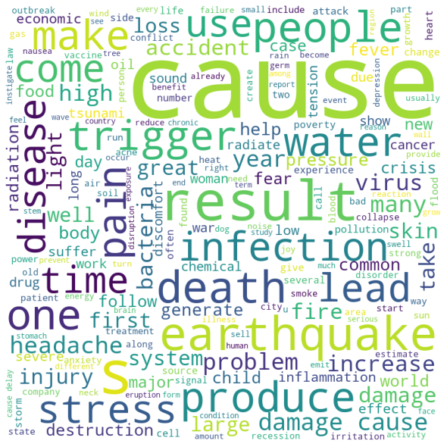

Figure Word Cloud from Cause-Effect Statements

In *Figure 12 Word Cloud From Cause-Effect Statements,* the number of times a word appears in the corpus corresponds with the font size of the word. As we can see, “cause” and “result” are the most repeated words in this corpus, which is in-line with what we are looking for as these words indicate a cause-effect type of relationship within the sentence. Other words that may be relevant are “trigger”, “make”, “lead”, “produce”.

As the data set was originally a multi-classification data set with 10 classifications, we converted the data set to be used for a binary classification of “cause-effect” versus “others”. However, when we looked at the frequency count of the samples, it was quite skewed. As seen in *Figure 13 Frequency of Classifications*, there were many more data samples in “Others” (0.0) as compared to “Cause-Effect” (1.0). The downside of using the data as-is is that the model will tend to classify more data as “Others” as a result. We will address this in the next section.

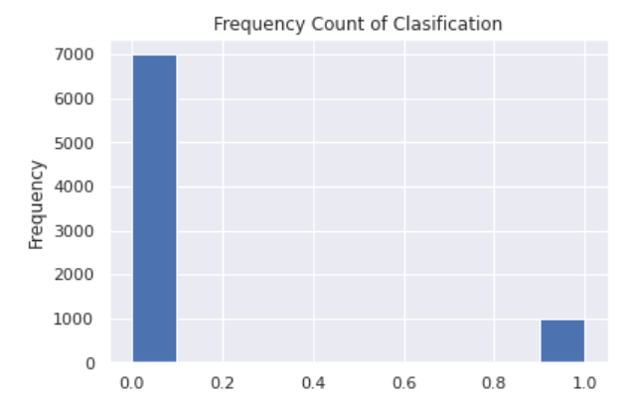

Figure Frequency of Classifications

Data Pre-processing

In any machine learning task, cleaning or pre-processing the data is as important as model building if not more. And when it comes to unstructured data like text, this process is even more important.

Steps we took for data pre-processing:

1. **Lower Casing**: Convert the input text into same casing format so that 'text', 'Text' and 'TEXT' are treated the same way. This helps in text featurization techniques as it helps to combine the same words together thereby reducing the duplication.
2. **Removal of Punctuations**: Remove the punctuations from the text data. This helps to standardize the text. Particularly for this dataset, we also removed the <e1> and <e2> markings, which indicated the entities in the text.
3. **Removal of stopwords**: Stopwords are commonly occurring words in a language like 'the', 'a' and so on. They can be removed from the text most of the times, as they don't provide valuable information for downstream analysis.
4. **Lemmatization**: Lemmatization reduces inflected words to their word stem but differs in the way that it makes sure the root word belongs to the language. For example, if there are two words in the corpus “creating” and “creation”, then stemming will return “creat” but lemmatization will return “create”. Lemmatization reduces duplication of words with essentially the same meaning and allows more accurate analysis.
5. **Tfidf-Vectorizer**: A system that incorporates both Count Vectorizer and Tfidf (Term Frequency Inverse Document Frequency) transformer to transform text into a meaningful representation of numbers. Count Vectorizer transform a given text into a vector based on the frequency (count) of each word that occurs in the entire text. Tfidf weights the word counts by a measure of how often they appear in the documents (Chaudhary, 2020).
6. **Random Oversampling**: Resampling involves creating a new transformed version of the training dataset in which the selected examples have a different class distribution. In our case, we had a skewed distribution and chose to use a random over sampler to balance the distribution. In the case of oversampling, examples in the minority class are randomly duplicated and added to the training dataset (Brownlee, 2020).

### Build, Train and Evaluate Model

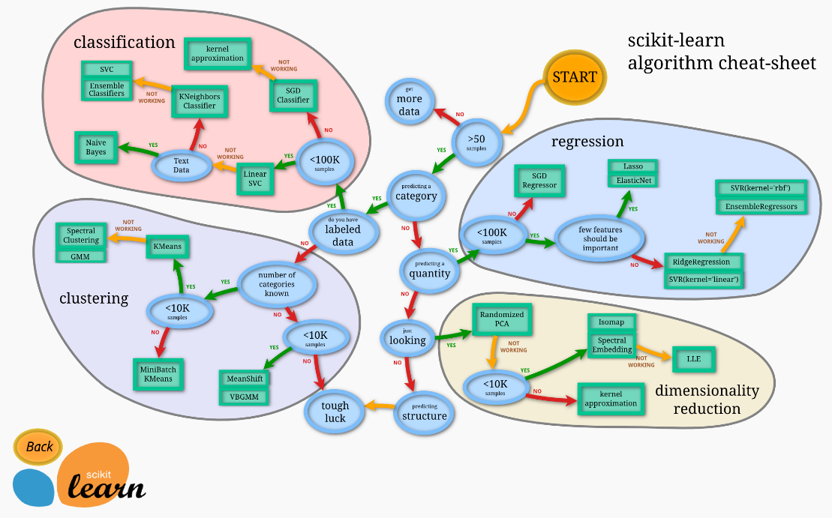

Figure Scikit Learn – Choosing an Estimator (Scikit-Learn, n.d.)

With 8000 samples in our train data, and predicting a category with labelled data, we identified 2 models - Linear SVC and Naïve Bayes models - to work on based on *Figure 14 Scikit Learn – Choosing an Estimator* (Scikit-Learn, n.d.), which outlines a map to choose a right machine learning model for our purposes.

In our evaluation of the models, we focused on 2 parameters, the accuracy, and the Cause-Effect F1-score. The accuracy gives a percentage of the total number of correctly classified data over the total number of test data. On the other hand, the F1-score is defined as the harmonic mean of the model’s precision and recall. Precision is the fraction of true positive examples among the examples that the model classified as positive. Recall, also known as sensitivity, is the fraction of examples classified as positive, among the total number of positive examples. Our results from testing the models are found in *Figure 15 Results from Model Testing*, which supports the use of a Linear Support Vector Model as it has a higher accuracy and F1-score.

|  |  |  |
| --- | --- | --- |
| Model Name​ | Final​ | |
| Accuracy​ | Cause-Effect F1-Score​ |
| Multinomial Naive Bayes ​ | 89.1​ | 0.66​ |
| Multinomial Naive Bayes (Alpha Optimized)​ | 92.6​ | 0.72​ |
| Support Vector Model​ | 95.2​ | 0.77​ |
| Linear Support Vector Model​ | 96.2​ | 0.84​ |
| Linear Support Vector Model (C Optimized)​ | 96.2​ | 0.84​ |

Figure Results from Model Testing

## Temporal Extraction

For temporal information extraction, we started off by looking at the type of information we wanted to extract. This would include dates in the format “DD.MM.YYYY”, “DD-MM-YYY”, “YYYY/MM/DD”, “DD MMM YY”, just to name a few. This would also include temporal information like “10 Months later”, “Next Decade”, “Two Years ago”.

We looked at the python library spaCy, which had an in-built function to pick out temporal information. However, this was slightly problematic as it could not recognize dates in certain formats like “DD.MM.YYYY”, and relevant information like “Q2”. We then looked towards working with Regular Expressions using the python library regex to supplement the spaCy library and pick out specific features where it fell short. However, due to the extensive types of date formats and information which might be missed by spaCy, we sought to find something more comprehensive in picking out the relevant information.

We chanced upon a transformer-based spaCy library which could load Hugging Face's transformers package, so we could use them in spaCy (spaCy, n.d.). The column “NLPDates” in *Figure 16 Temporal Information Extraction Results* gives the return for temporal information with normal spaCy library, and the column “TRFDates” gives the return for temporal information with the transformers package. Using the transformer library, we achieved much better temporal information extraction as shown.

Figure Temporal Information Extraction Results

The codes for cause-effect modelling and temporal information extraction we developed were shared with Panasonic’s data science team for their use in establishing and testing these modules with internal data. *Figure 17 Journey with Panasonic* shows the breakdown, after the satisfactory delivery of the codes, we moved on to develop a prototype for a product that would integrate news data into a demand forecast dashboard. The design of this prototype will be covered in the next section.

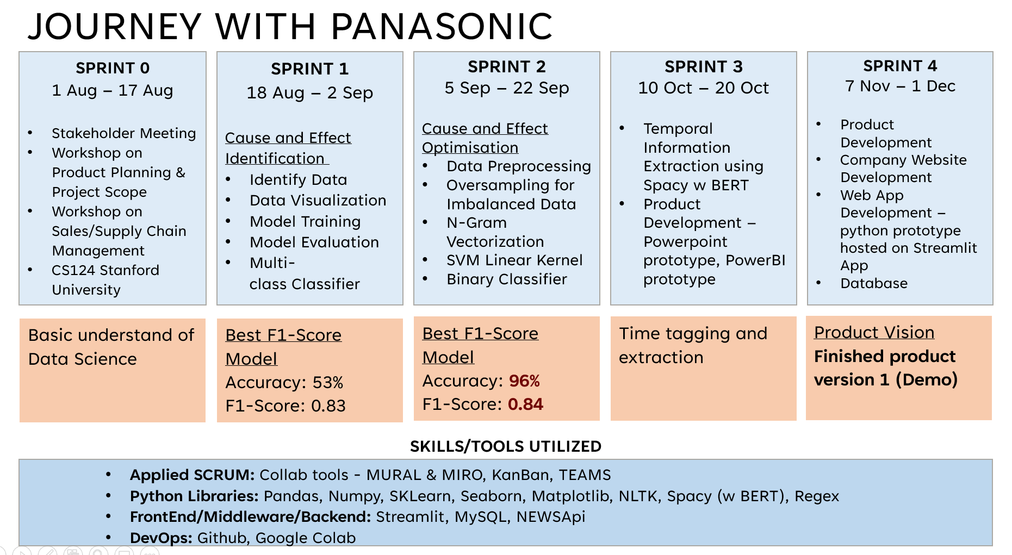

Figure Journey with Panasonic

## Design and Prototype

### Product Inspiration

We took reference from user interfaces we had come across to start designing our prototype. One of the references we found which had achieved the look we wanted came from Google Finance. In *Figure 18 Screenshot of Google Finance Interface*, you will see a screenshot of a dashboard with integrates a numerical chart (for stock price) with indicators for news events. In addition to the event indicators, an interface also provides more information on the events, and a calculation on how much the stock price had changed on the same day of that event.

Figure Screenshot of Google Finance Interface

### Wireframing Using PowerPoint

In addition to looking at reference user interfaces, we also conducted an interview with a sales and marketing professional to flesh out what would be a useful for a user of such a dashboard.

The key features were:

1. Event indicators flag
2. Interactive data table showing the events and corresponding date
3. Percentage impact of that event to the demand

Other hygiene factors included:

1. Easy uploading/integration of data in excel format
2. A clean interface
3. The ability to allow for user-input data with regards to the percentage impact of the event and saving this user-input data to a database.

Based on our product inspiration and the interview, we came up with a wireframe of our product in PowerPoint, which can be found in *Figure 19 Wireframe in Powerpoint*.

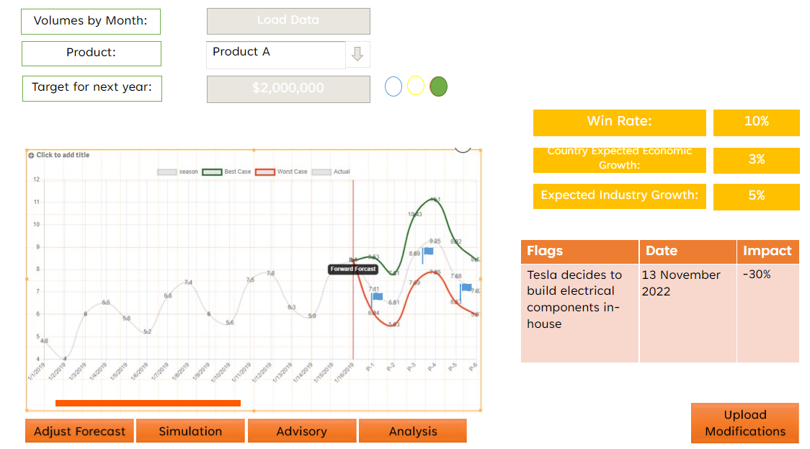

Figure Wireframe in PowerPoint

### Prototype Design

Leveraging on the skillsets we had built during the course, we worked towards translating our PowerPoint Wireframe into a web app.

In our prototype, the user can perform the following actions:

1. Upload an excel file
2. View plotted line chart and provide an interactive experience to zoom in and out on certain parts of the trend line and forecast
3. View indicators for news events on chart *(Figure 20 Forecast Chart with Event Indicators*)
4. View news and projected impact in table
5. Input and save estimated impact and business strategy to a database (*Figure 21 Interactive Events Table)*

Our web app can be found at: https://beatriceyapsm-capstonebackend-backendapp-t5spbq.streamlit.app/

Figure Forecast Chart with Event Indicators

Figure Interactive Events Table

## IT Landscape

From our discussion with Panasonic, we understand that their forecasting dashboard is currently in an excel file. We had considered using PowerBI for developing this solution due to the easy integration of excel files into PowerBI. However, PowerBI supports a limited number of python libraries (Bothma, 2022) and had constraints to make further customisations to the interface. Important NLP related libraries like spaCy are also not available for use within PowerBI.

We looked for a platform to run python codes easily and without restrictions on the libraries. Streamlit was our chosen platform for the development of this web app, as it offers an open-source app framework for running python codes. We used the following python libraries to build the prototype: streamlit, streamlit_timeline, pandas, numpy, altair, prophet, aggrid and pymysql.

Figure IT Landscape for Our Prototype

Future enhancements for the prototype to be integrated into Panasonic’s IT landscape:

1. Sales trend automation instead of manual upload
2. News database from web scraper/News API
3. Model predictions to be saved in database
4. Estimated impact to synchronise with current AI forecast for reinforced learning
5. Business strategy to synchronise with CRM (Customer Relationship Management)

# Feasibility Analysis

## Economic Feasibility

Supply chain demand forecasting can leverage the capabilities of Machine Learning to potentially improve the accuracy rate of demand forecast, track the ever-changing market conditions, and reduce costs in the operation.

### Improved Accuracy

Machine learning can collect and process massive amounts of data in a brief period. It can also identify complex patterns that may not be recognized by human analysts. Since our product embeds NLP to analyse unstructured text like news articles, the data is generated constantly and globally, and it is impossible for human analysts to process and interpret this large amount of data while still producing accurate predictions. The edge of machine learning help businesses to do more accurate strategic demand planning for their operations and inventory management.

### Enhanced Speed

Machine learning continuously collects data in real-time according to the market, to learn and adapt to the latest market trends and consumer behaviour. It helps businesses make changes according to the market and consistently stay ahead of competition. The ML Techniques generate between $3.5 trillion to $5.8 trillion value annually. (Rai, Tiwari, Ivanov, & Dolgui, 2021)

### Enhanced Efficiency

Machine learning with a high accuracy rate reduces risks such as overstocking and stock-out. It improves inventory management and reduces costs. For example, it gives confidence and negotiation power to purchase managers to purchase larger stocks with a lower price when machine learning can predict an increasing demand in the future. This helps the business owners avoid risk of overstocking and allow businesses to manage resources in an efficient way. According to a study, machine learning improved cash conversion cycles with a reduction of 21 days. Inventory turnover improved by 0.17 turns compared to the baseline figure. (Feizabadi & Shrivastava, 2018) On the other hand, businesses can negotiate flexibly terms with their suppliers when the prediction is not in their favour.

### Reduce Costs

Using machine learning for demand forecasting can help organizations save on labour costs by automating the forecasting process. It can also help reduce the costs associated with making incorrect assumptions or decisions, which can have a major impact on an organization's bottom line. For example, Panasonic is looking to invest $4 billion to build an additional electric vehicle (EV) battery plant in the United States (Jaiveer Singh Shekhawat, 2022) Panasonic could use the outputs from MIRAI’s forecast as a factor in the decision of whether to proceed with the plant (Magee, 1964)

### Value Chain Analysis

Forecasting is a process every company uses to plan, execute, manage, and monitor its performance. Understanding the companies value chain will help the company to gain insight into what goes into each of its transaction for the product and by maximising it, it would allow us to better define the value of the product or service. (Stobierski, 2020)

Primary Activities:

* Inbound logistics
* Operations
* Outbound logistics
* Marketing and sales
* After-sales service

Secondary Activities:

* Procurement
* Technological development
* Human Resources Management
* Infrastructure

Figure Components of a Value Chain (Stobierski, 2020)

|  |  |  |  |
| --- | --- | --- | --- |
| **Inbound Logistics** | **Operations** | **Outbound Logistics** | **Cost Reduction** |
| Interest cost  Shipping  Storage – Raw Material | Storage – Work in Progress  Rejected  Obsolesce | Operating Interest cost  Shipping  Storage- Finished Goods | Total Cost Reduction |
| ↓ 1% ~ 5% | ↓ 1% ~ 5% | ↓ 1% ~ 5% |
|  |  |  | ROI = Cost Reduction/ Cost of MIRAI |

Figure Value Chain Cost Benefit ROI Calculation

We did a simplified approach to calculating the value of MIRAI by looking at the 3 main activities, Inbound Logistics, Operations and Outbound Logistics with reference to Panasonic’s Annual report. With the assumption of a 1% to 5% reduction in cost in each of the components, we find that having MIRAI would provide a minimum ROI of 15 times.

## Technology Feasibility

Our current solution is hosted on Streamlit’s free hosting platform. While Streamlit offers an easy and seamless continuous integration/continuous deployment process when integrated with GitHub repositories as we have experienced in running this project, there are some shortfalls for launching it to production. A main concern for a large organization like Panasonic would be data security and privacy of the technology. In Streamlit, there is a setting to restrict access to users based on their emails, however, it is very primitive (keying in the emails one by one) and can be difficult to manage in a large organization. In addition, the suggested authentication method uses a “secrets.toml” file which is not secure and does not have password hashing. A feasible way to increase the security and authorization process could be to use Django’s authentication framework to secure the app, as it offers better security and an administrator console for user control (Murallie, 2022).

## Schedule Feasibility

Our solution outlined has a pipeline of 4 modules. The first module (web crawler) has been developed by Panasonic prior to our project, and the next 1.5 modules (cause effect & temporal information extraction) have been delivered in this project within a period of 2 months (18 Aug – 20 Oct). The next step to work on is the event extraction and linkage with temporal information, followed by the sentiment analysis on these events. We estimate that these 1.5 modules will take another 2 months to develop and another 2 months for integration into existing software systems, taking a total of 4 more months for deployment. This time frame is like the results of Algorithmia’s survey, in which 50% of respondents indicated a timeframe of 8-90 days for machine learning deployment (per module) as seen in *Figure 25 Time it takes to deploy an ML model into production (Algorithmia, 2019)*

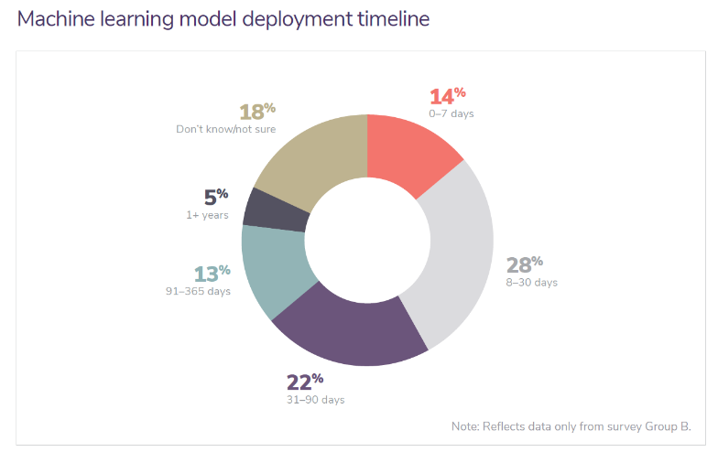

Figure Time it takes to deploy an ML model into production (Algorithmia, 2019)

# Financial Aspects

As the venture is set up to develop a qualitative analytics solution for a Capstone project client and unfunded during the 4-month project work, the team must explore various revenue models to sustain the venture in the years post project work. We applied the Lean Canvas to map out our business plan. Below we discuss the revenue streams and the mechanics of pricing.

## Revenue streams

All business models need to make profits after deducting expenses from the sales to be sustainable eventually. As an IT start-up consultancy providing customised demand forecasting solution, the model is different than the usual model of established non-tech corporations.

In the case of pricing a software development project, choosing the right pricing model matters as much as the price itself (Butel, 2018). The pricing model should reflect the relationship between the customer and the developer. When we want a long-term partnership with clients, we would want to be on the same team as them, hence we would price our models to reflect this. The 3 common models are Time and Material (T&M), Fixed Price, and Sprint Pricing.

We considered 3 revenue streams for the venture: IT Business Consultancy, Software Subscription, and Training Revenue. Developing the MIRAI App falls under IT business consultancy. Once it is commercialised, it will contribute a software subscription revenue stream. Training revenue will start when we help the client and employees at the deployment and maintenance of the software. The pricing structures are discussed below.

### Time and Material

A simple model where client pays an hourly rate for each hour worked, plus any out-of-pocket expenses incurred. Clients sometimes do not like this model as it can feel like there is no certainty on the cost and the outcome. Certainty would come through how the team runs the product development and the desired outcomes can be met cheaper on T&M than on the Fixed Price model.

### Fixed Price

This method may look like what most clients normally want to have. However, this will depend on knowing what specifications the Client wants and developer knows what to build before team starts on the project. Once developer starts, any modifications, new knowledge or improvements will be added as change requests. Fixed price model may appear to control cost and manage cost from spiralling it carries the highest risk that the project delivers the wrong software. The thinking behind this model is that once the job is delivered, the team will move on to other things. It is commonly adopted by outsourced service providers.

One way to manage this type of project is to break it down into smaller and manageable pieces which allows for review between the smaller pieces. We could manage it using Kanban, to limit the amount of work that has started but not yet delivered. This forces a continuous flow, as the customer is signing off work at the same rate as new work commences. It should be noted that if the customer is not signing off as quickly as the developer delivers the product, it will cause a bottleneck. Allowing for a WIP (work in progress) limits helps to identify where the bottleneck lies, and the developer can slow down production to match the speed of the bottleneck.

### Sprint Pricing

This model is adopted if a product team is hired. With a limited budget, a fixed number of people will be hired thus providing a fixed number of resources. The team works in sprints to achieve the goals. There is an agreed cost per sprint. This model means the team is working towards an agreed upon objectives. The desired behaviour is to have a motivated team who gets both intrinsic and extrinsic rewards seeing the shipped software is according to agreed goals. It is important to note that the team may not achieve everything that was planned. The remaining work would be re-prioritised to the next Sprint. Daily stand-ups and sprint review provide visibility on the progress.

A summary table containing the comparison of T&M, Fixed Price and Sprint Pricing is shown.

Figure Comparison of Various Pricing Models

The benefit in doing sprints is the continuous delivery of a working software, and it fosters the opportunity for review and learning. Future sprints can be planned after gaining new knowledge which improves decision making and more accurate estimates.

Spring Pricing is like T&M; however, it has a maximum budget per Sprint. It could have a variable scope. Sprint differs from T&M in that the product team takes ownership of a product and works to deliver the best outcome.

Since the objective is to reward and align with a desired behaviour, both the T&M and Fixed Pricing do not fall under “on the same team” behaviour which is displayed by a Product team using Sprint. Our team identifies with the Spring Pricing model for the development of MIRAI product.

## Project Venture Business Outlook

In the first two years of the venture with our client, Panasonic, we will focus on developing a tailor-made solution for demand forecasting using AI and ML. The solution is based on issues and pain points that Panasonic is facing. Sentiment Analysis for demand forecast is a niche area that is still being researched on (Wood, 2014). Currently this concept is still in its infancy (Teo, 2020)and our research shows it has an enormous potential when we have a viable product to showcase to Panasonic. Once the Proof of Concept is commercialised, we will roll it out to the other companies in the same verticals. Thereafter, the vision is to cover all other industries that are capable of being transformed using this technology. We are confident of a viable product, as Panasonic has a dedicated team of Data Scientists who are already researching and testing algorithms for specific analytics. Moreover, Panasonic owns Blue Yonder, an established American software and IT consultancy company offering supply chain management and manufacturing planning. It could be a huge resource for our collaboration under the Panasonic partnership.

We have discussed with other start-ups and found there is a thriving IT business consultancy in the current economic and digital transformation landscape. Buy-in from our client is essential for the minimum viable product to be tested for Proof of Concept (PoC). Post-project work, the PoC to be become further developed before it is commercialised and for the team to monetize it along the journey. Currently, under project work, the team works from home with personal resources, leveraging open-source software. We plan to charge IT Consultancy fees and training fees during the period of collaboration and R&D under the Panasonic partnership.

# Kaizen/ Agile Methodology

We have proceeded with Kaizen/Agile Approach in implementing this project using the SCRUM methodology to deliver value to our stakeholders within the 4 months period.

We adopted the main Agile Values, which increased collaboration within the team and with our stakeholders – Panasonic, Instructors and Mentors.

* Individuals and interactions over processes and tools
* Working software over comprehensive documentation
* Customer collaboration over contract negotiation
* Responding to change over following a plan

This allowed us to continuously improve and deliver value based on the requirement of our stakeholders through the Kaizen philosophy of continuous improvement (Do, 2017):

* Identify a problem or opportunity
* Analyse the process
* Develop an optimal solution
* Implement the solution
* Study the results and adjust
* Standardise the solution

Figure Initial Project Scope by Panasonic

*Figure 27 Initial Project Scope by Panasonic* shows the initial project scope by Panasonic, that the delivery of the model would be in the third month. By dissecting the scope into sprints, we were able to bring value to Panasonic in within the first month as seen in *Figure 17 Journey with Panasonic.*

## Change Management

Change management was implemented throughout the project from project scope discussions, product backlog prioritisation, sprint planning and sprint reviews. All changes identified were then added to our Product Backlog on a Kanban and prioritised through Sprint Planning at the beginning of each sprint.

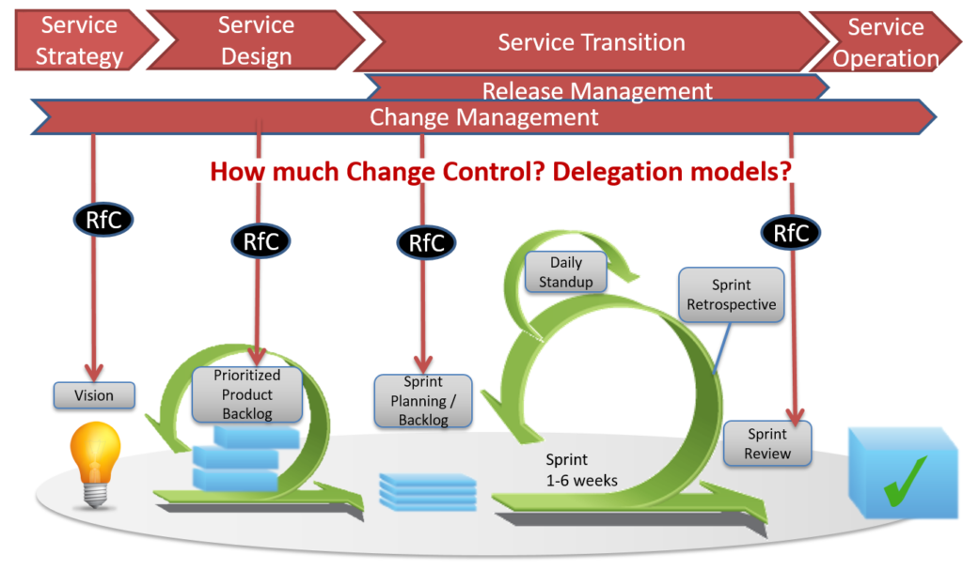

Figure Scrum & ITIL: A perfect fit on high level (Lichtenberger, 2014)

### Communication Plan

We followed the Agile/SCRUM Framework closely to keep communication open and transparent, and adapt to changes as we progressed along with the project

* Daily Stand-up for 15 minutes daily walking-the-board to align goals, project tasks and blockers
* WhatsApp and Teams were used to communicate with all stakeholders for any impromptu communications
* Weekly meetings with Panasonic
* Review sessions before every mini capstone presentation with Mentor and Instructor on top of the scheduled meetup
* Weekly updates through email to our Mentor and Instructor
* Sprint Review and Retrospective sessions after each sprint

### Implementation through Collaboration

Collaboration was a key focus of the project given the time and resource that we had, implementation was carried out in 5 sprints starting out with Exploration Phase – Sprint 0.

* All our source codes were written on Visual Studio Code and are uploaded/synchronised to Google Colab and GitHub
* MURAL and MIRO were used for brainstorming and retrospectives
* Kanban for segregation of tasks, managing delivery of deliverables, and identifying risks and bottlenecks.
* TEAMS was used to store all project artifacts and documentations

## Risk Management

Like change management, through the Kaizen continuous improvement, risk was being monitored throughout the sprint cycle, and members of the team were able to raise any risks during daily stand-ups and sprint retrospective, while stakeholders can raise any concerns during sprint review and increment phases or through feedback forms. Risks were then changed into user stories and added into our Product Backlog/Kanban and prioritised before each sprint.

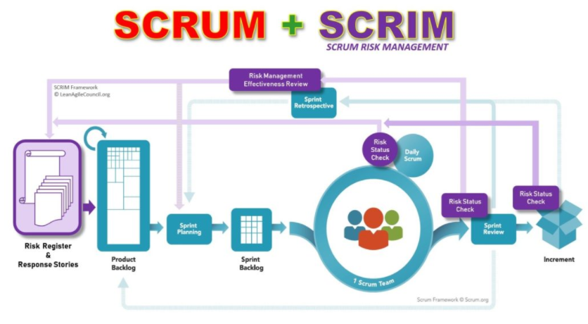

Figure Management of Risks in a Scrum Environment (Oswal, 2021)

### Timeline and Skillset

During project selection, we selected this project as it excited us, being in a completely new domain – Machine Learning, and it was not part of the SGUS (SGUnited Skills) FinTech syllabus. The main risk highlighted was how we would be able to learn an entirely new within 4 months on top of regular coursework and deliver at the same time.

* Stakeholder expectation setting on the team’s capacity, skill, project scope and course schedule
* Re-evaluation of scope after each sprint based on retrospective from the team and sprint review feedback from Panasonic, Instructors and Mentors.

With this we managed to deliver more value than the original scope together as a team.

### Technology

This project was not just a new domain, the technology was also new to us.

* Spent time during Sprint 0 to learn Machine Learning, Explore Data Sets, Explore Research Papers on NLP, and Demand Forecasting
* By having incremental delivery, we were able to learn and apply what we have learnt into deliverables for the project
* Instead of building the models from scratch, we referenced available open-source models and improved them incrementally
* Wireframing was done on PowerPoint first to have a basic visualisation of the end MVP
* Prototype was done on HTML/CSS/JS and PowerBI before finalising on Streamlit

# Conclusion

As AI adoption is becoming more mainstream, we are proud to be a part of it. By implementing it together with Panasonic, it gave us better understanding on the overview on AI Project implementation and the benefits and constraints of AI in demand forecasting.

Our key learnings from the project include:

1. People

It is important to know your key stakeholders and ensure that there is collaboration, and constant communication going on to manage expectations. Team collaboration was also especially important as everyone is from different background, it was great to be able to tap on the different skills each had to offer to deliver more.

1. Processes

Understanding the business processes is essential in model and product development, in the ideal scenario, we would have been able to provide greater value if Sales and Marketing teams were involved and had access to internal datasets.

1. Tools

The SGUS NUS FinTech course we learnt that there is never only one way/tool to implement the same thing, it also gave us a toolkit which helped us to kick start the journey. Although we had to acquire our own AI/ML skillset to fulfil the requirements of Panasonic, we were able to use the understanding and knowledge gained to deliver this project.

The learnings are also in alignment with the survey done by McKinsey on high performing AI adopters compared to other companies where AI high performers tend to engage in value-capturing practices. (Arif Cam, 2019)

Figure Global AI Survey: AI proves its worth, but few scale impact

Considering the brief time span of the project, there was a limit to what we could achieve and deliver. However, we foresee this project to continue within Panasonic in future sprints:

Figure Future Sprints of MIRAI

# Demonstration and Documentation of Solution

## Overall Process

## Step 0: Visit MIRAI Website

Visit MIRAI’s: <https://mirai9c.netlify.app/>

Click on Demo

## Step 1: Visit the Dashboard

Visit MIRAI’s dashboard: [MIRAI 未来 · Streamlit](https://beatriceyapsm-capstonebackend-backendapp-t5spbq.streamlit.app/)

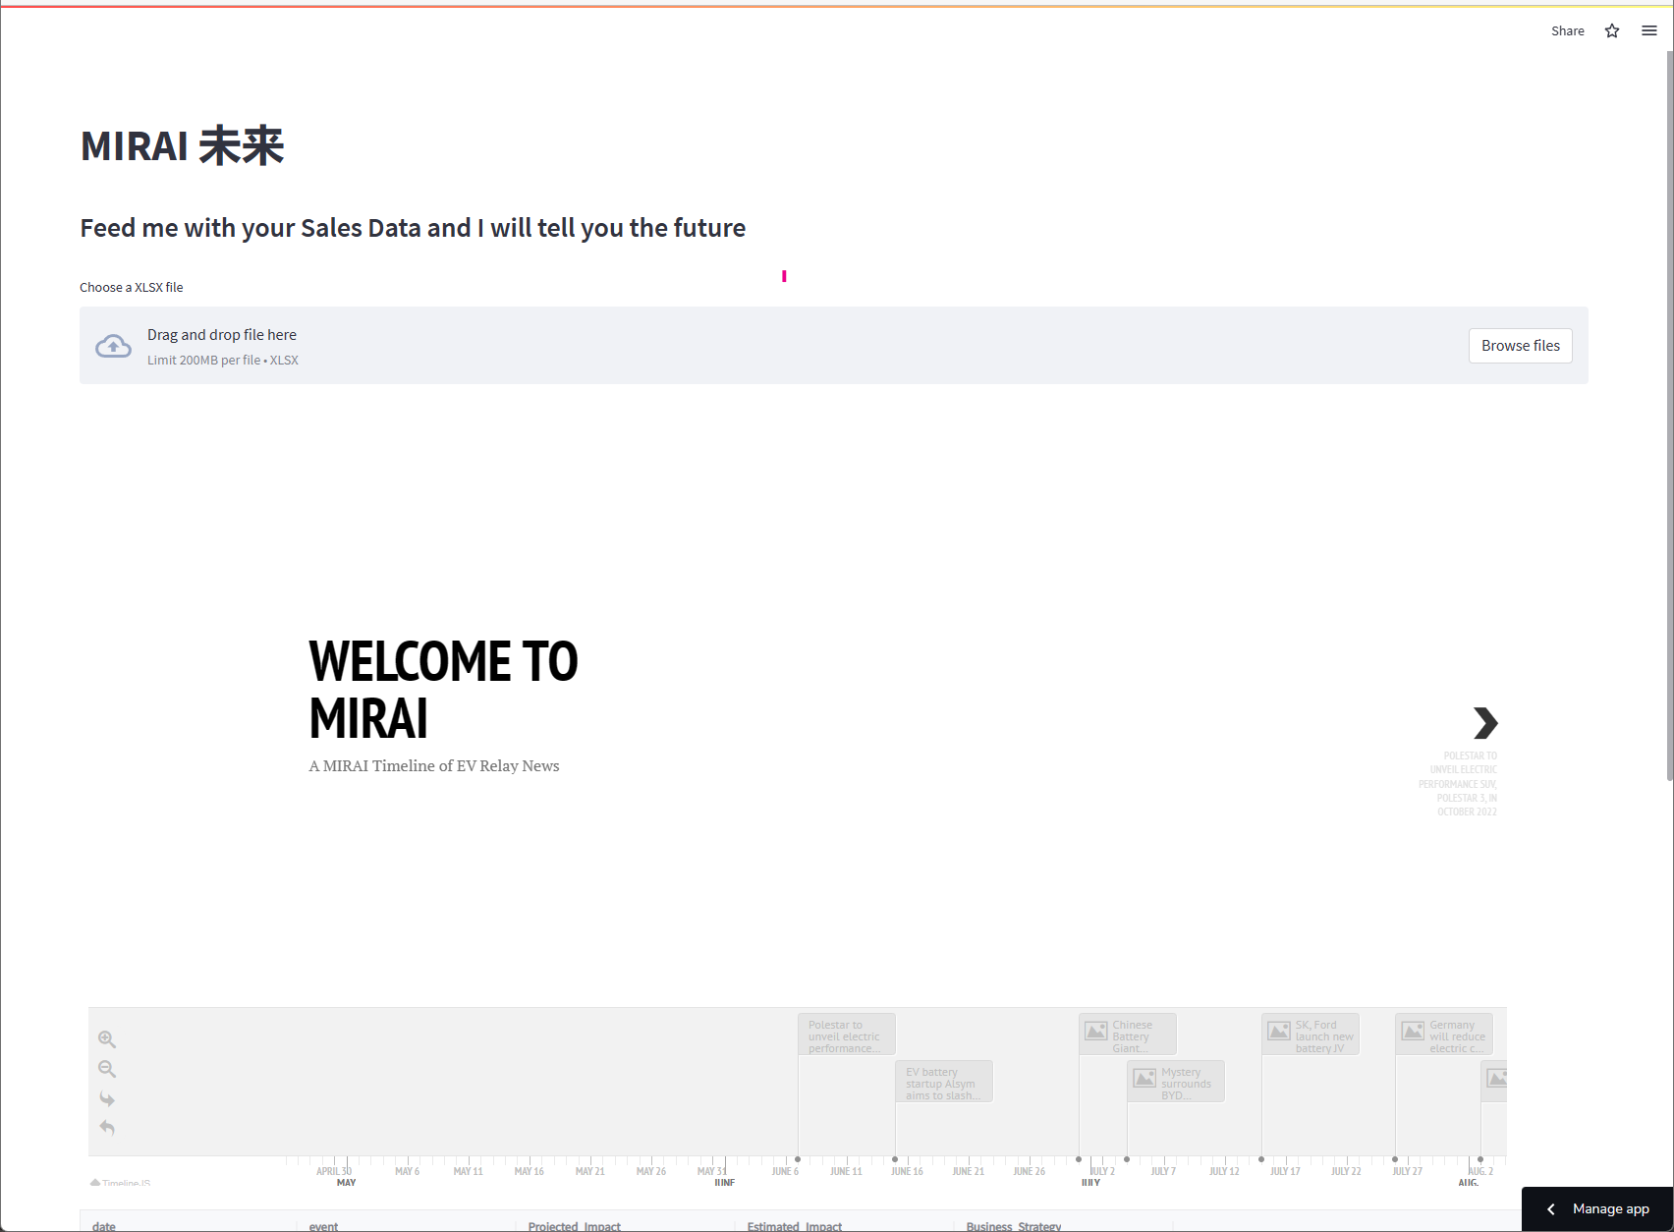

## Step 2: Upload the data

For demonstration purposes, please download this Panasonic EV Relay2 file [here](https://nusu.sharepoint.com/:x:/s/9CCapstoneProject/Eb24ju3466pEp68Zjp7Y5TIBJzG74yyPuP9OtGTk6tWvyg?e=vj0ksV).

(Please sign in to your NUS account)

2.1 Panasonic EV Relay2 file:

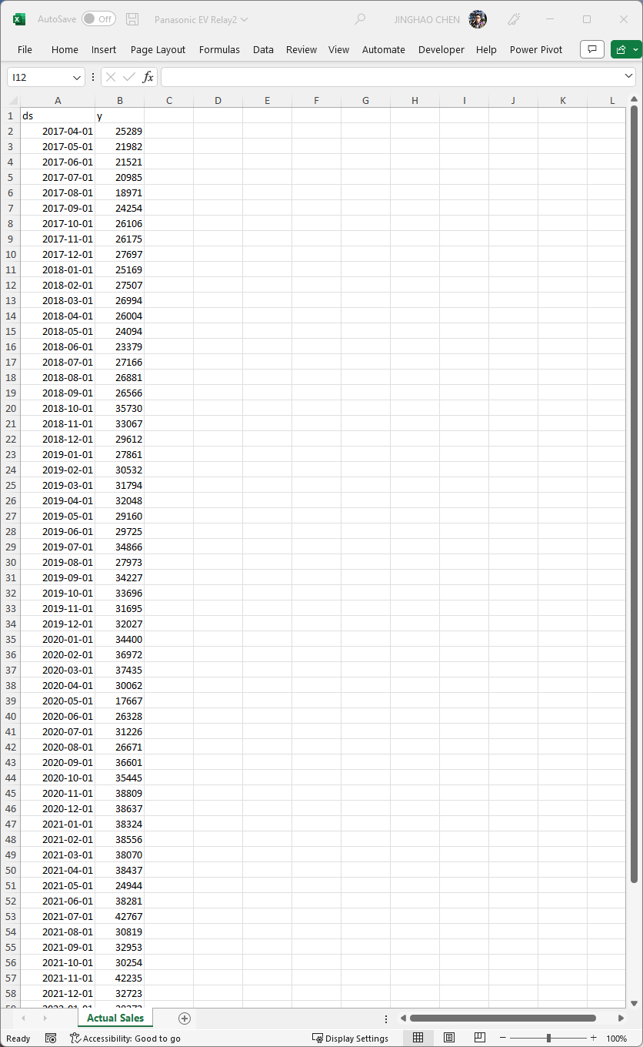

2.2 Upload the data

## Step 3: Demand Forecast Chart

A Forecast Demand chart will be generated on the dashboard base on the data you uploaded.

The system will automatically generate six monthly forecasts in a yellow line based on uploaded data. All events picked up by the system will present as the red down arrow to identify the actual time of occurrence.

## Step 4: Event Detail

The detail of the event will show in slices and a timeline below the forecast demand chart.

The users can browse the events by pressing black arrows on both sides of the slices. Users can press the Read more button to obtain the article if any further detail is needed. Users are also given the option to fast locate the event through the timeline function below. Any event selected in the timeline component; the selected event will show in the slice.

## Step 5: Impact Table

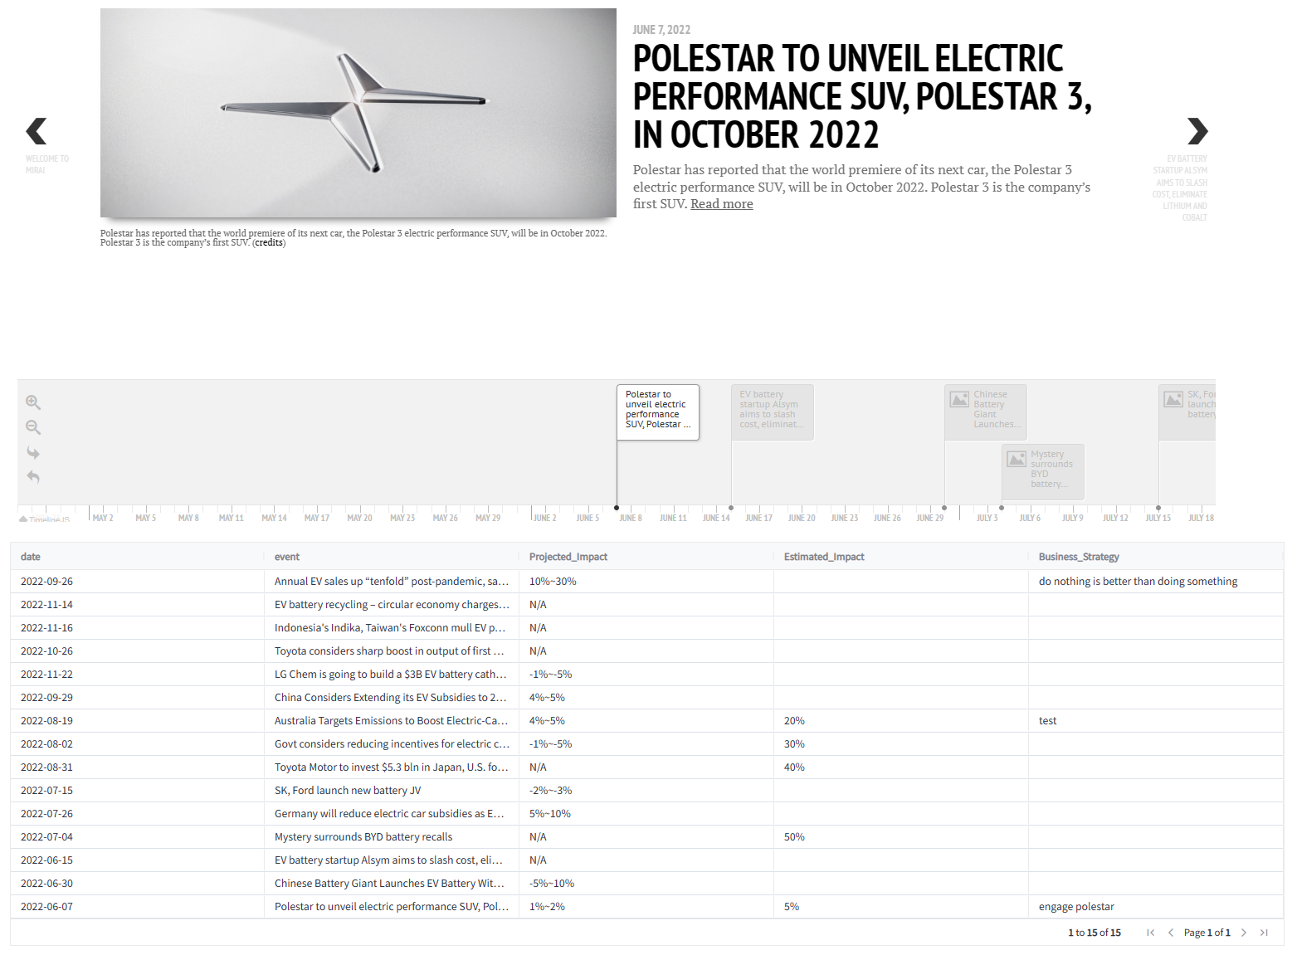

The events picked up by the system will list in the impact table with the detail of time, title, and projected impact. The number of project impact is produced by the system backend.

Users can provide their number in the Estimated Impact column based on their experiences. This could be used in the future for reinforced learning, to improve the aggregation model.

The follow-up action can be added to the Business strategy column.

(For demonstration, you need to press any other space in the table. This allows the streamlit-aggrid to store your data.)

## Step 6: Upload the data

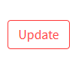

When the user updates the impact table, an Update button needs to press to save the work and upload it to the database. The team will be able to see the updated impact table. In the future, this data could be synchronised with third party software such as salesforce to follow up on the action.

## Python Codes

1. Cause-effect identification Models: <https://github.com/squaluz/Group-9C-Capstone/blob/main/2A%20SemEval10%20Binary%20Classification.ipynb>
2. Combined cause-effect identification and temporal information extraction to extract news: <https://github.com/squaluz/Group-9C-Capstone/blob/main/3%20SVM%20Binary%20Classification%20with%20Temporal%20Extraction.ipynb>
3. Prototype Launched in Streamlit: <https://github.com/beatriceyapsm/capstonebackend/blob/main/backend/app.py>

# References

Algorithmia. (2019). *2020 state of enterprise machine learning.* Retrieved from Algorithmia: https://info.algorithmia.com/hubfs/2019/Whitepapers/The-State-of-Enterprise-ML-2020/Algorithmia_2020_State_of_Enterprise_ML.pdf

Arif Cam, M. C. (2019, November 22). *Global AI Survey: AI proves its worth, but few scale impact*. Retrieved from McKinsey: https://www.mckinsey.com/featured-insights/artificial-intelligence/global-ai-survey-ai-proves-its-worth-but-few-scale-impact

Bothma, J. (2022, June). *Running Python Scripts in Power* *BI Tutorial*. Retrieved from Datacamp: https://www.datacamp.com/tutorial/running-python-scripts-in-power-bi-tutorial

Brenner, R. (2020). *TechTalk Building Software that matters:Business Agility*. Retrieved from https://techtalk.at/blog/how-does-pricing-work-for-agile-contracts/?lang=en

Brownlee, J. (2020, Jan 15). *Random Oversampling and Undersampling for Imbalanced Classification*. Retrieved from Machine Learning Mastery: https://machinelearningmastery.com/random-oversampling-and-undersampling-for-imbalanced-classification/

Bruin, L. d. (2016, 18 9). *Business-to-you*. Retrieved from Scanning the Environment: PESTEL Analysis: https://www.business-to-you.com/scanning-the-environment-pestel-analysis/

Butel, A. (2018). *Agile Product Development Pricing*. Retrieved from https://blog.end-game.com/agile-product-development-pricing-55199cede75c

Cannone, P. (2021, August 26). *Five Ways Artificial Intelligence Will Change The B2B Marketing Industry In The Next Four Years*. Retrieved from Forbes: https://www.forbes.com/sites/forbesagencycouncil/2021/08/26/five-ways-artificial-intelligence-will-change-the-b2b-marketing-industry-in-the-next-four-years/?sh=1f6490dd50b2

Chaudhary, M. (2020, Apr 24). *TF-IDF Vectorizer scikit-learn*. Retrieved from Medium: https://medium.com/@cmukesh8688/tf-idf-vectorizer-scikit-learn-dbc0244a911a

Do, D. (2017, August 5). *What is Continuous Improvement (Kaizen)?* Retrieved from The Lean Way: https://theleanway.net/what-is-continuous-improvement

Feizabadi, J., & Shrivastava, A. (2018). Does AI-enabled demand forecasting improve supply chain efficiency? *Supply Chain Management Review*, 8-10.

Gately, C. (2017). *Vekia: pioneering machine learning in retail supply chain.* Small Enterprise Research.

Jaiveer Singh Shekhawat, H. J. (2022, 8 27). *Reuters*. Retrieved from Tesla supplier Panasonic plans additional $4 bln U.S. EV battery plant - WSJ: https://www.reuters.com/business/autos-transportation/panasonic-plans-additional-4-bln-ev-battery-plant-us-wsj-2022-08-26/

Kabongo, G. (2021, Dec 2). *Success Strategies for Demand Forecasting in Supply Chain*. Retrieved from ToolsGroup: https://www.toolsgroup.com/blog/demand-forecasting-in-supply-chain/

Leenatham, A., & Khemavuk, P. (2020). Demand Forecasting Using Artificial Neural Network Based on Quantitative and Qualitative Data. *2020 1st International Conference on Big Data Analytics and Practices (**IBDAP).* IEEE.

Lichtenberger, V. A. (2014, July). *Integrating Agile and ITSM*. Retrieved from Distruptive Agile Service Management: https://blog.itil.org/2014/07/integrating-agile-and-itsm/

Magee, J. F. (1964, 7). *Harvard Business Review*. Retrieved from https://hbr.org/1964/07/decision-trees-for-decision-making: https://hbr.org/1964/07/decision-trees-for-decision-making

Marilú Destino, J. F. (2022, 2 9). *McKinsey & Company*. Retrieved from To improve your supply chain, modernize your supply-chain IT: https://www.mckinsey.com/capabilities/operations/our-insights/to-improve-your-supply-chain-modernize-your-supply-chain-it

Murallie, T. (2022, May 16). *Control Who Could Access Your Streamlit Dashboards*. Retrieved from The Analytics Club: https://www.the-analytics.club/streamlit-advanced-authentication

NewsAPI. (n.d.). *Search News and Blog Articles on the Web*. Retrieved from News API: https://newsapi.org/

Oswal, S. (2021, July 20). Retrieved from Management of Risks in a Scrum Environment: https://www.linkedin.com/pulse/management-risks-scrum-environment-santoshkumar-oswal

Panasonic Group. (2022). *Report on Financial Results and* *ESG.* Osaka: Panasonic Hodings Corporation.

Pentecoste, A. (2022). Demand Prediction in Retail. In P.-E. G. Maxime C. Cohen, *A Practical Guide to Leverage Data and Predictive Analytics.* Switzerland: Springer Cham.

Placek, M. (2022, September 23). *Statista*. Retrieved from Automotive electronics worldwide - statistics & facts: https://www.statista.com/topics/7983/automotive-electronics-worldwide/#topicOverview

Plex DemandCaster. (n.d.). *Demand Forecasting: An Industry Guide*. Retrieved from Plex Demand Caster: https://www.demandcaster.com/demand-forecasting-an-industry-guide/

*Precedence Research*. (n.d.). Retrieved from Electric Vehicle (EV) Relay Market: https://www.precedenceresearch.com/electric-vehicle-relay-market

Rai, R., Tiwari, M., Ivanov, D., & Dolgui, A. (2021). Machine learning in manufacturing and industry 4.0 applications. *International Journal of Production Research*, 4773-4778.

Research and Markets. (2022). *Augmented Analytics Global Market Report 2022.* Research and Markets.

Research Reports World. (2022, November 7). *MarketWatch*. Retrieved from Global EV Relay Market Size 2022 | Share, Regional Trend, Future Growth, Leading Players Updates, Industry Demand, Current and Future Plans | Forecast to 2028: https://www.marketwatch.com/press-release/global-ev-relay-market-size-2022-share-regional-trend-future-growth-leading-players-updates-industry-demand-current-and-future-plans-forecast-to-2028-2022-11-07

Rheude, J. (2022, 8 11). *Red Stag Fulfillment*. Retrieved from Demand Forecasting: Types, Methods, and Examples: https://redstagfulfillment.com/what-is-demand-forecasting/

Scikit-Learn. (n.d.). *Choosing the right estimator*. Retrieved from Scikit-Learn: https://scikit-learn.org/stable/tutorial/machine_learning_map/index.html

SemEval: International Workshop on Semantic Evaluation. (2010). *sem_eval_2010_task_8*. Retrieved from Hugging Face: https://huggingface.co/datasets/sem_eval_2010_task_8

Singh, M. (2022, October 19). *Yahoo! Finance*. Retrieved from Automotive Relay Market to Exceed US$ 26.5 Billion by 2032 with Emergence of Self-diagnosing Smart Vehicles: https://finance.yahoo.com/news/automotive-relay-market-exceed-us-153000418.html

spaCy. (n.d.). *spacy-transformers*. Retrieved from spaCy Universe: https://spacy.io/universe/project/spacy-transformers

Stobierski, T. (2020, 12 3). *What is a value chain analysis?* Retrieved from Harvard Business School: https://online.hbs.edu/blog/post/what-is-value-chain-analysis

Teo, W. W. (2020). *A Natural Language Processing Approach to Improve Demand Forecasting in Long Supply Chains, in partial fulfilment of the Requirements for the degree of Master of Engineering in Supply Chain Management at the MIT.* Cambridge: MIT.

Walley, P. (2017). *Open University*. Retrieved from Reading: Introduction to operations management: https://www.open.edu/openlearn/money-business/business-strategy-studies/introduction-operations-management/content-section-2

Wood, L. C. (2014). *Sentiment Analysis in Supply Chain Management. In W. John (Ed.), Encyclopedia of Business Analytics and Optimization (pp. 2147-2158).* Hershey, PA, USA: IGI Global.

# Appendix

## PowerBI Prototype

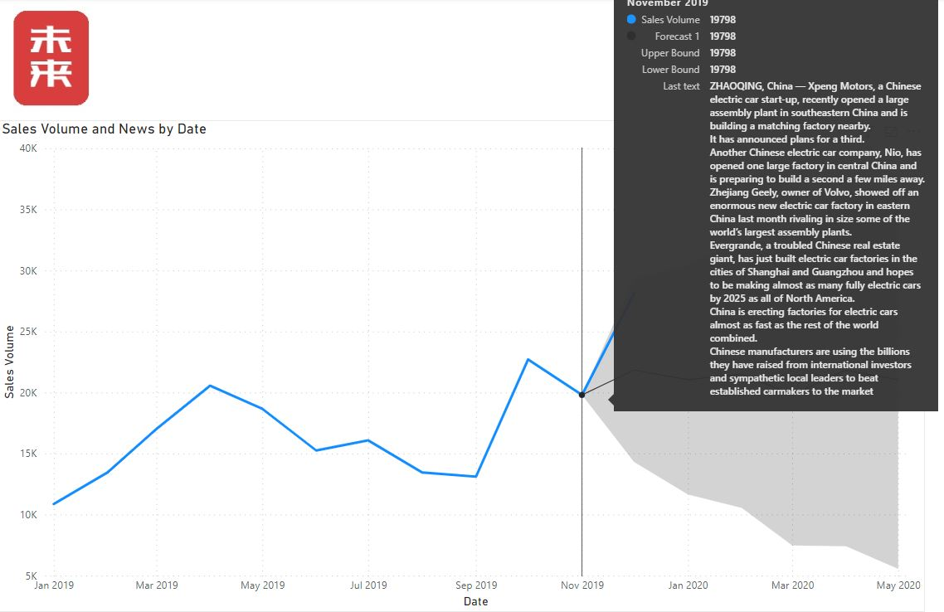

## Agile Methodology

### Daily Standup

### Kanban

### TEAMS Collaboration – Internal & Stakeholders

### Information Repository – One Note

### Retrospectives

### Sprint Schedule Planning

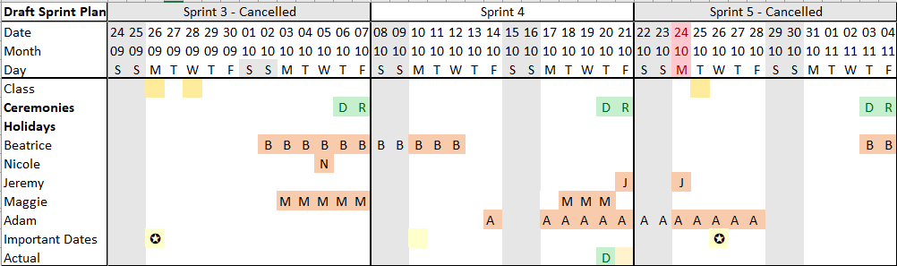

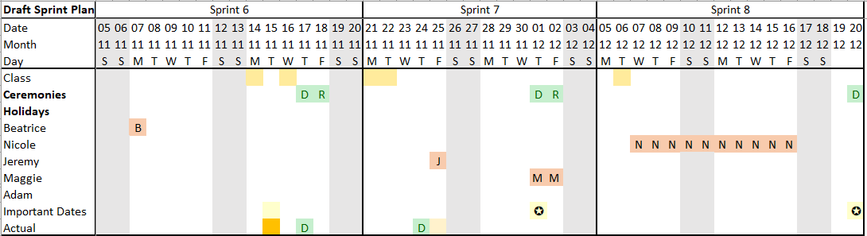

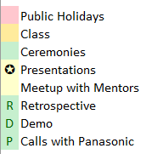

## Lean Canvas

|  |  |  |  |  |
| --- | --- | --- | --- | --- |
| **Customer Problems**   * Current demand forecasting is very tedious and time consuming * Analysis and forecasting can be bias-heavy   **Existing Alternatives**   * Manual Methods | **Solutions**   * An interactive app for forecasting with embedding of news articles | **Unique Value Propositions**   * Tailored consultancy to integrate MIRAI into current demand forecasting systems for easy access * Simplifies the task of browsing through news and tallying effects to the business. | **Unfair advantages**   * First-mover advantage to address natural language processing for demand forecasting * IP: Pipeline developed and tested; we have developed intellectual property in this area. | **Customer Segments**   * Existing Partner Companies:   + Panasonic B2B EV Relay Sales and Marketing Teams   + Other Panasonic B2B Business Lines * Businesses that have multiple SKUs, with high holding inventory cost, and high-value goods that will cause significant hit to the revenue/profitability if there are missed sales or service   + Energy Sector (eg. ExxonMobil, Shell)   + Airplanes Sector (eg. Boeing) |
| **Key Metrics** *(Key activities to measure success*)   * Improve forecast accuracy (reduce forecast to actual gap) * Reduction in time to preparing demand forecasting reports | **Data we need to make better decisions.** (What data do we need to make fact-based decisions?) List out the data elements you need   * Current and historic news * News sentiments vs product sales * Historical actions ft Sales history + Profitability analysis * Sales Volume, Pipeline, contractual conditions, Opportunity profile * Supply Chain Plan and policies | **Channels**   * Word-of-mouth * Partner with Demand Forecasting (Quantitative Methods) software with affiliate marketing |
| **Cost Structures**   * Salaries – high * Shared Office space – low * IT Equipment – low * Office Software – low * G&A - low   + Accounting (outsourced)   + Company Secretary (outsourced) | | **Skill Sets Needed**   * Project Management * Natural Language Processing * Full stack programming * Data Science * Research & communication * QA/QC * Business Operations Analysis | **Revenue Streams**   * Software Subscription Fees: Start off with 2-year free subscription for partner companies whom we will work with to improve our software and track metrics * Consultancy & Customization Fees * Training Fees | |